1) Home Page Before Login/Signup

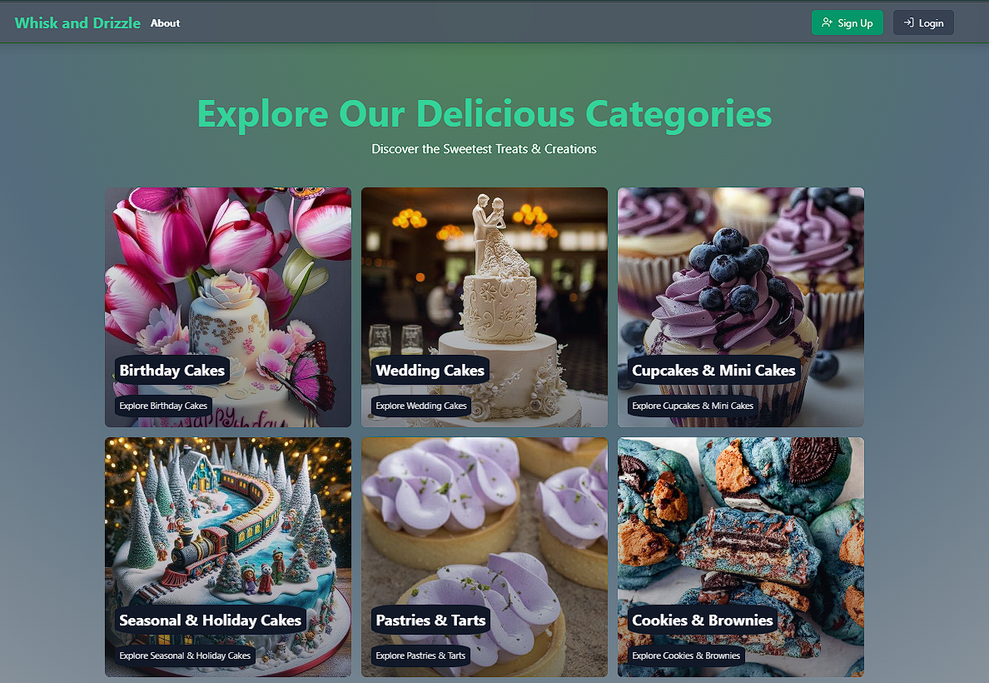

2) Registration Page

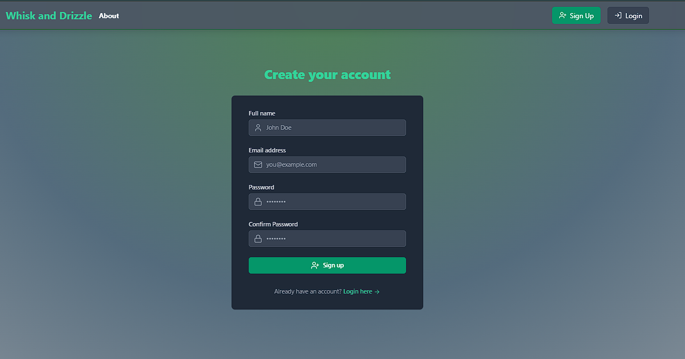

3) Login Page

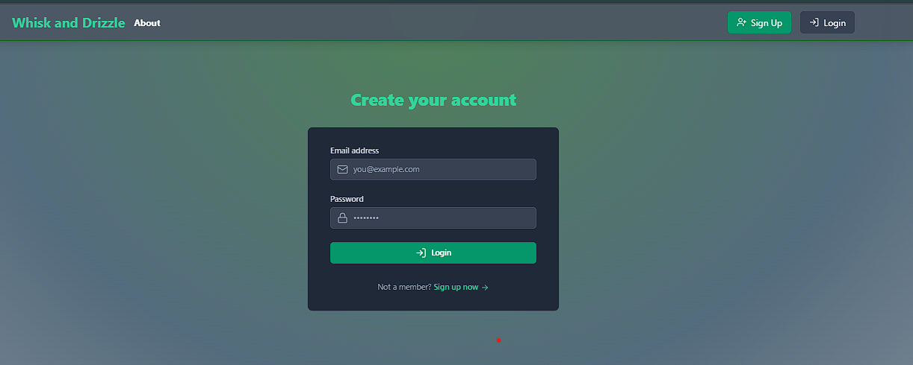

4) Customer Logged in Page (Without Dashboard opton)

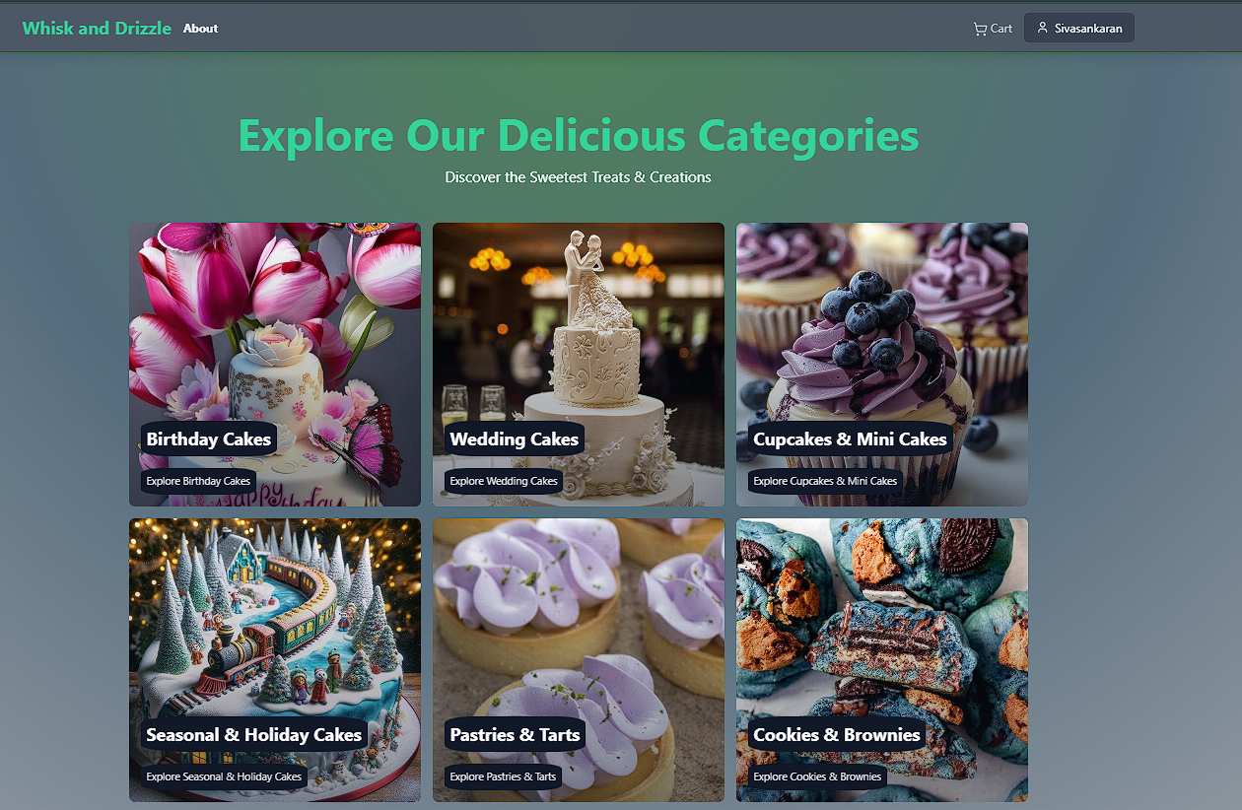

5) Admin Logged in Page (With Dashboard option)

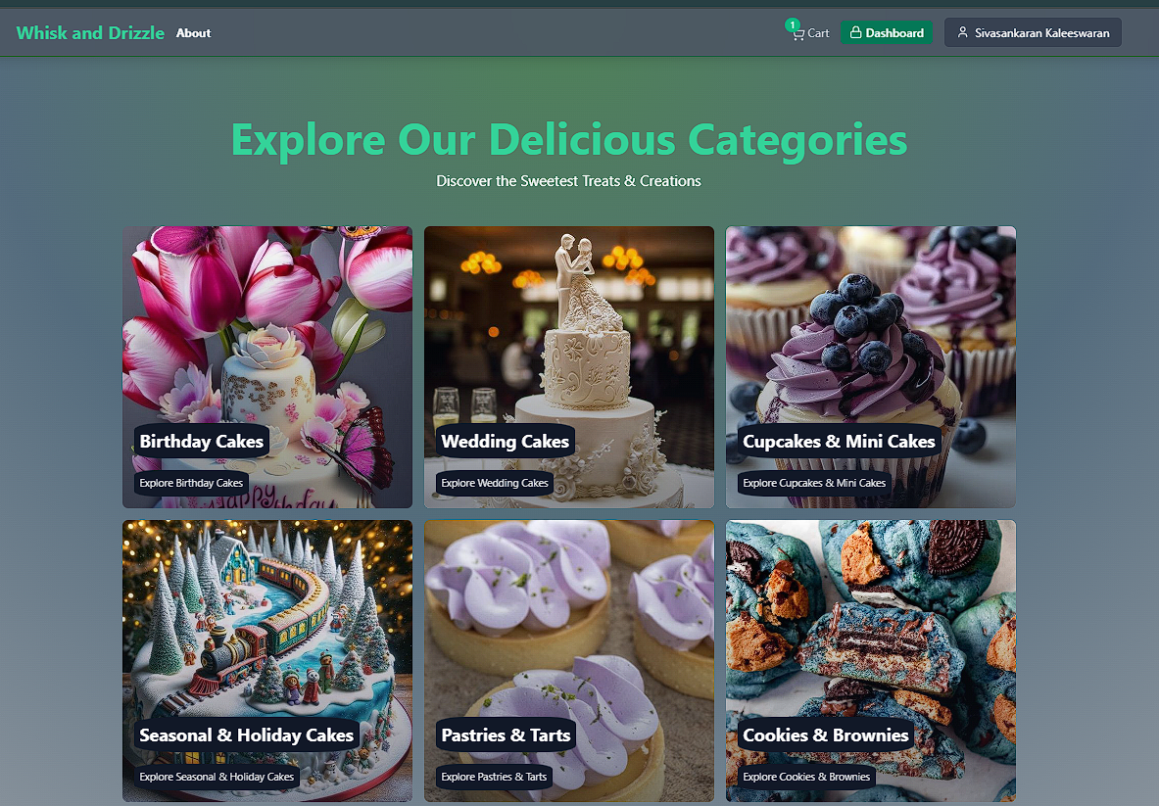

6) Logout

